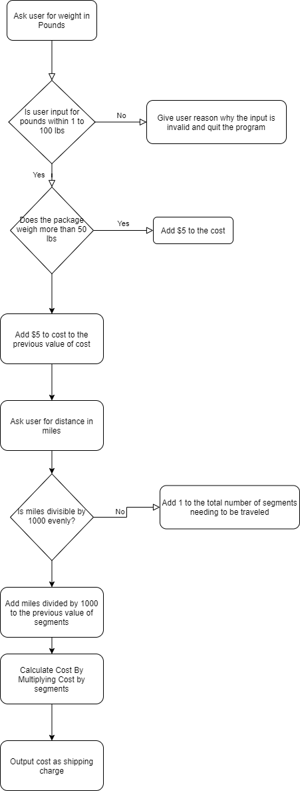

#include<stdio.h>

#include<stdlib.h>

/*Juan Velasquez 2/16/2021

This program takes in 2 parameters being weight, in pounds, and distance needing to

be traveled, in miles, for the shipping of a package and calculates the cost

according to the standards of Global Courier Services.*/

main()

{

//Instantiation and Init user inputs

int pounds, miles, seg;

pounds = 0;

miles = 0;

seg = 0;

////Instantiation and Init output variable

double cost = 0;;

//Asking the user for the desired weight of the package and setting 'pounds' equal to the input.

printf("\nPlease Input the Weight of Your Package in Pounds: ");

scanf_s("%i", &pounds);

//checking if the user input is valid, if not, it will return a reason why and quit the program.

if (pounds > 100) {

printf("\nSorry, we only ship packages of 100 pounds or less.");

return 0;

}

if (pounds < 1) {

printf("\nSorry, we only ship packages of at least 1 pound or more.");

return 0;

}

//Checking the rate to charge for the package based on weight, this will later be multiplied by the segments of 1000 miles.

if (pounds > 50) cost += 5;

cost += 5;

//Asking the user for the desired distance for the package to travel and setting 'miles' equal to the input.

printf("\nPlease Input the Distance Your Package Must Travel in Miles: ");

scanf_s("%i", &miles);

//Checking if the number of miles can be divided evenly by 1000, if not, add one more segment to the total as you cannot have a fraction of a segement.

if (miles % 1000 != 0) {

seg++;

}

//Then add what miles/1000 is to the previous result.

seg = seg + (miles / 1000);

//Calculate cost by multiplying the rate previously calculated by the total number of segments.

cost = cost * seg;

//Print the result

printf("\nYour shipping charge is $%.2lf", cost);

}

